Clever Badges is only available for students K-6. Follow these directions to print a classroom set of badges:

1. Log into clever and you can see your dashboard, click on classes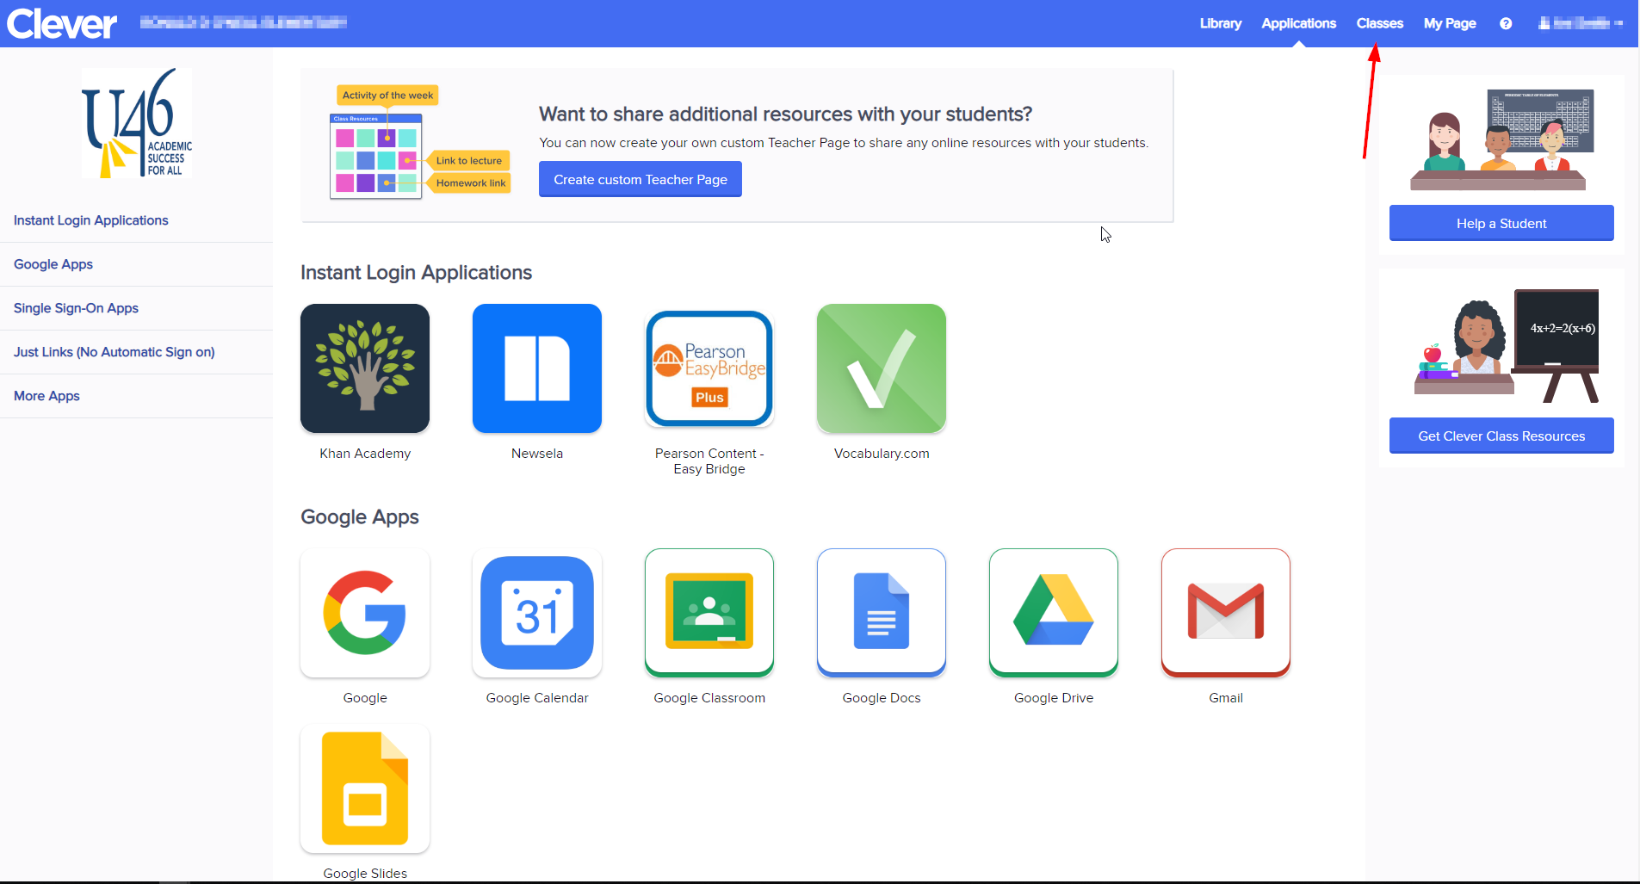
2. Click on your class homeroom

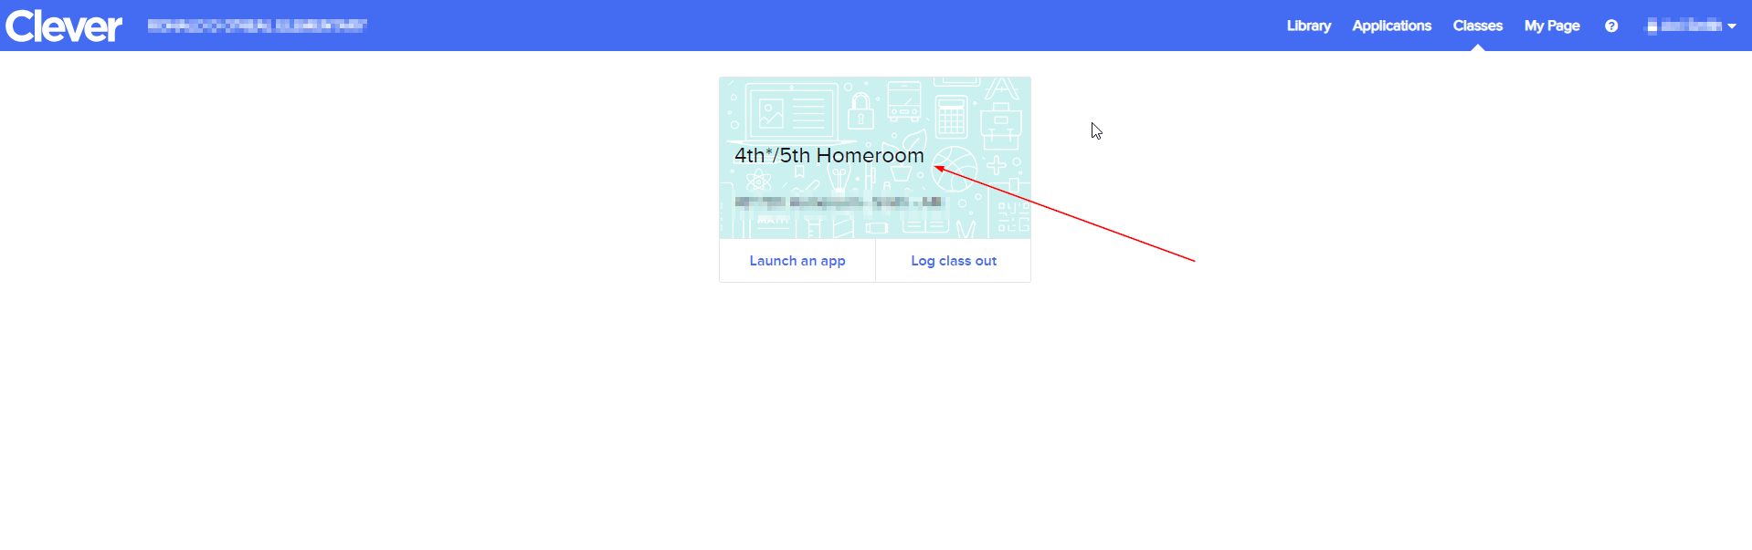

1. On the upper right hand corner underneath your name you can download your full class set of badges. It downloads in a pdf.

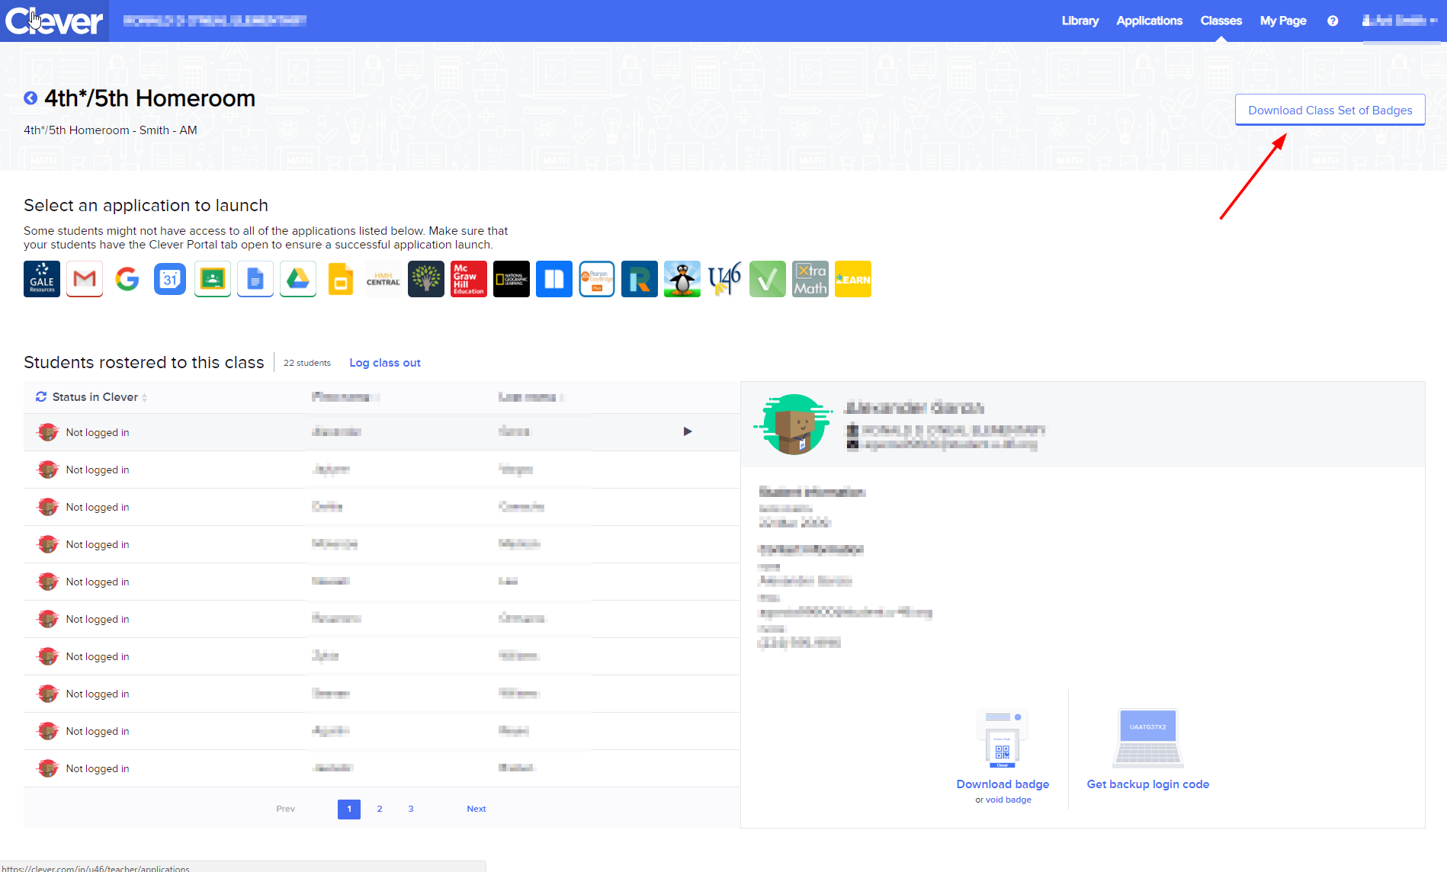

1. To download individual student badges, follow the steps above but scroll down on the left and click on the student. Then in the window on the right you will see a button to download the students badge, as shown in the picture below.

